PJATK

**Final project**

for IPB subject

Vladyslav Hrabets

S18376

# Introduction

As of right now there are many delivery services that can provide food and grocery. However, they do not provide alcoholic products as it is requiring additional step age check. There are web sites that have listings of beverages but most of them rarely updated and those which are mainly based on one type like scotch or bourbon specifically.

The main idea for the project is catalog web site with basic functionality of social network for alcoholic beverages with ability to provide contact info to order them.

The system be able to deliver its contents to user to view and provide information how to buy it.

The process begins when User wants to browse products. They visit web site and selecting “View retailers”. System displays retailers by descending order of location. And when User selects a retailer. After that System displays products that they can sell. User shall add products to cart and sends order to retailer. The retailer reviews the order and can send confirmations with payment methods. If so, User opens the order, chooses available convenient payment type, pays for the order.

# BUSINESS USE CASE DIAGRAM

# BUSINESS ANALYSIS DIAGRAM

# BPMN FOR CURRENT FORM

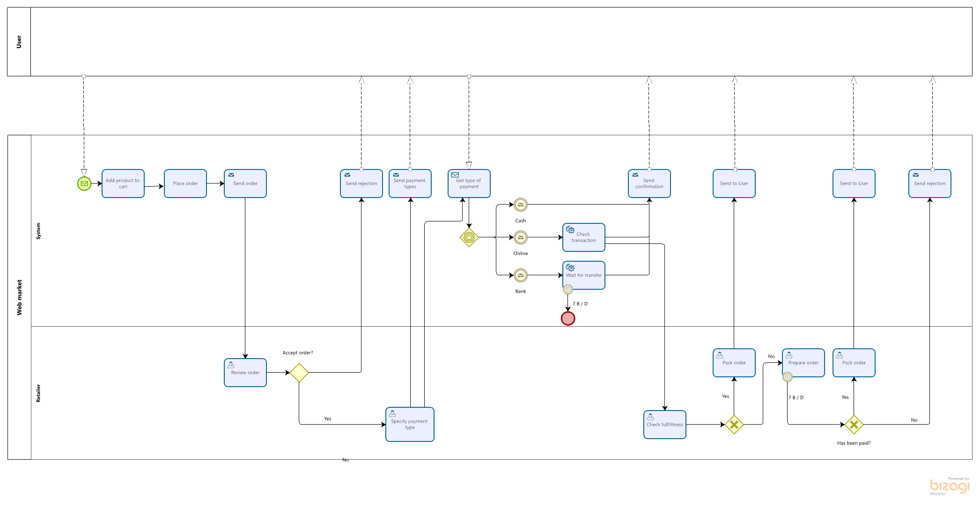

# BPMN FOR NEW FORM

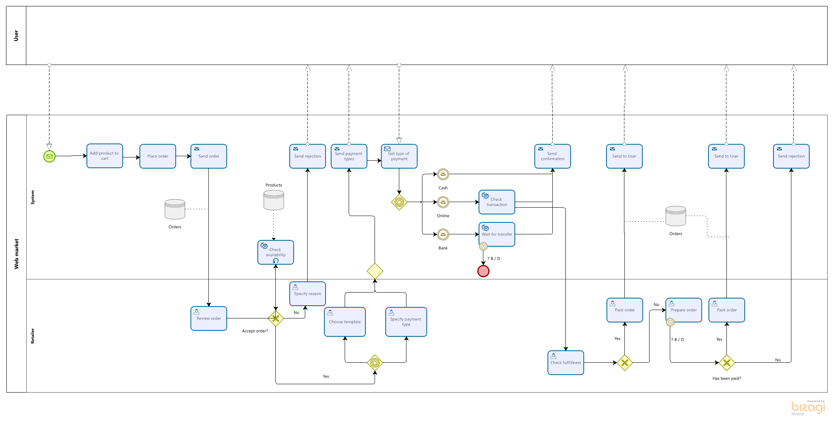

# USE CASE DIAGRAM

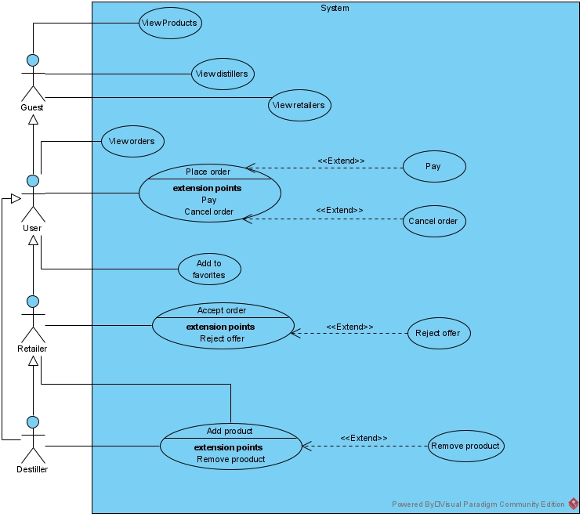

# CLASS DIGRAM

# Prototype

Mock up web site for the project available under the [LINK](http://project4237072.tilda.ws/).